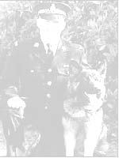
PC Dog Handler - Ged Walker

Memorial Dog Show

West Park Long Eaton
(Close to M1 Junction 25)

Show opens at 10.30am
Judging commences 12 noon

Show Sponsored by Skinner’s pet food

11 Pedigree Classes

15 Novelty Classes

14 GSD Fun Classes

Ged Walker Memorial Class, judged by a Police Dog Handler

L Cpl Kenneth Rowe & Sasha Memorial Class

L Cpl Liam Tasker & Theo, Trophy

Theo & Sasha's Dickens Medal, Memorial Class

Fun Agility, Fastest Recall,

Stalls, Refreshments

SUNDAY 14th JULY 2019

All proceeds donated to:
C.O.P.S. (at the request of PC Ged Walker’s family) and to Help for Heroes
Contact:
Mrs J Wesley 0115 8462031 or 07913838593
Mrs S Foreman 0775 4918089

Classes are £1.50 each or 5 for £5

Schedule & Entry Forms available online: www.worldofdogs.cc

