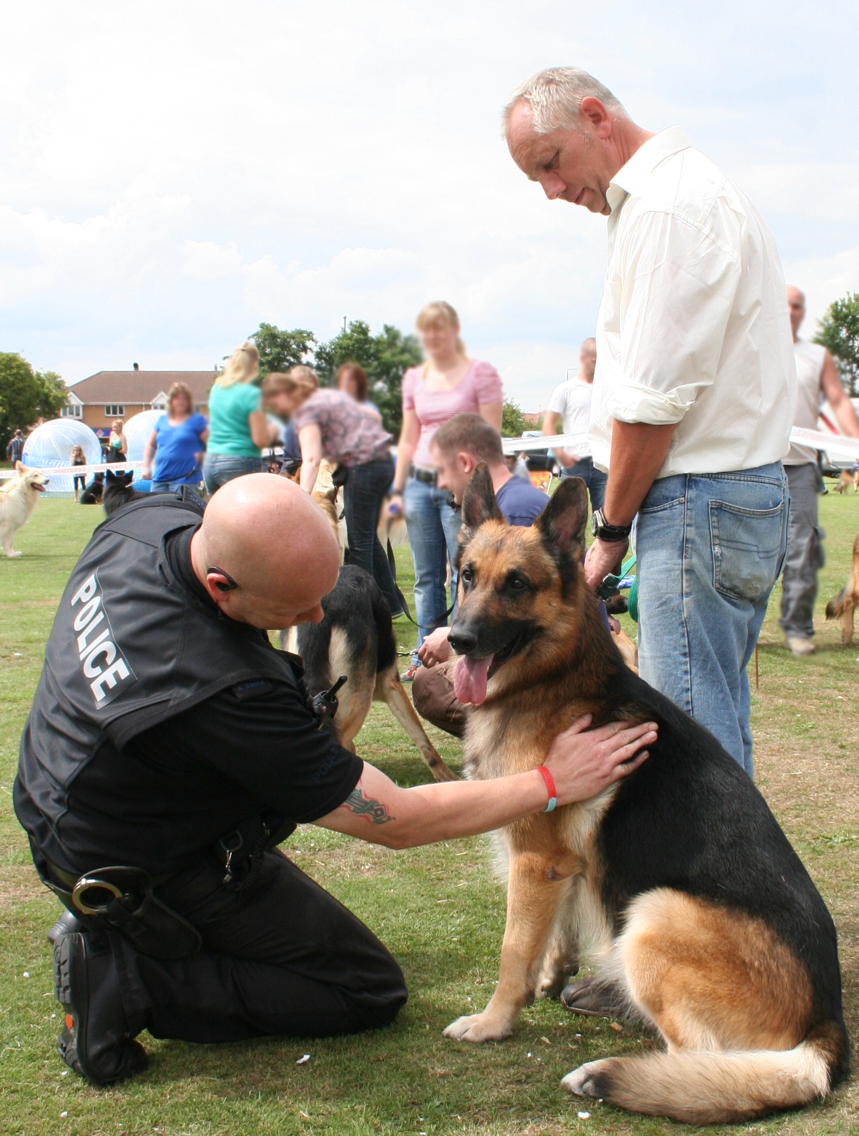

Show Sponsored by

PROCEEDS DONATED TO
C.O.P.S
(at the request of PC Ged Walker’s family)
& to HELP for HEROES

Organised by
THE OLD PARK FARM DOG TRAINING & DISPLAY TEAM

Who wish to thank everyone for their
hard work and support in making this show possible.

PC DOG HANDLER

SUNDAY 14th JULY 2019

West Park – Long Eaton
Nottinghamshire NG10 4AA
(OFF JUNCTION 25 M1)

SHOW OPENS 10.30am

JUDGING 12 NOON

Rosettes to 6th place in all classes
CLASSES AT £1.50 PER CLASS or 5 classes for £5

EVERYONE WELCOME

CONTACT: MRS J WESLEY 01158 462031 or
07913838593
MRS S FORMAN 0775 4918089
www.WorldOfDogs.cc (entry form/details)
PEDIGREE CLASSES

1) ANY VARIETY BABY 12weeks to 6 months
2) ANY VARIETY PUPPY 6 months to 12 months
3) ANY VARIETY GUNDOG
4) ANY VARIETY HOUND
5) ANY VARIETY PASTORAL
6) ANY VARIETY TERRIER
7) ANY VARIETY TOY
8) ANY VARIETY UTILLITY
9) ANY VARIETY WORKING
10) ANY VARIETY OPEN
11) L Cpl Kenneth Rowe & Sasha – OPEN MEMORIAL CLASS
(open to all Gun Dogs) (Free entry)

BEST IN SHOW RESERVE BEST IN SHOW
BEST PUPPY IN SHOW

GERMAN SHEPHERD FUN CLASSES

12) BABY (WHITE LONG & STANDARD COAT) 12wks to 6 months
13) PUPPY (AS ABOVE) 6months to 12 months
14) JUNIOR (AS ABOVE) 12MONTHS TO 18MONTHS
15) BEST WHITE COAT DOG
16) BEST WHITE COAT BITCH
17) BEST COLOURED LONG COAT DOG
18) BEST COLOURED LONG COAT BITCH
19) BEST STANDARD COAT DOG
20) BEST STANDARD COAT BITCH
21) VETERAN 7 YEARS +
22) PRETTIEST BITCH
23) HANDSOMEST DOG
24) BEST CONDITION
25) OPEN MEMORIAL CLASS FOR PC GED WALKER
(Open to all German Shepherds) (Free Entry)

BEST OF BREED BEST PUPPY IN BREED

NOVELTY CLASSES

26) BEST JUNIOR HANDLER (under 16 yrs old)
27) PRETTIEST BITCH
28) HANDSOMEST DOG
29) BEST RESCUE
30) BEST PUPPY CROSS BREED
31) BEST CROSS BREED
32) BEST VETERAN from 7 yrs to 10 years
33) BEST VINTAGE from 10 yrs and above
34) WAGGIEST TAIL
35) BEST SIX LEGS
36) BEST MATCHED BRACE
37) BEST UNMATCHED BRACE
38) BEST CONDITION
39) BEST UGLY MUSH
40) THE DOG THAT THE JUDGE WOULD LIKE TO TAKE HOME

BEST IN SHOW RESERVE BEST IN SHOW

(IN THE EVENT THAT A CLASS IS VERY FULL IT WILL BE SPLIT)

**************************************************************
L Cpl Liam Tasker & Theo
TROPHY**
**Awarded to the overall winner chosen from the winners of:-
11) L Cpl Kenneth Rowe & Sasha OPEN MEMORIAL CLASS
25) OPEN MEMORIAL CLASS FOR PC GED WALKER
**************************************************************
Theo & Sasha’s Dickens Memorial Medal
TROPHY class***
***(Open to All 1st place class winners, from any section of the show, Pedigree, Novalty, GSD and Obedience) ***(No Entry Fee)
**************************************************************
PAY AT THE RING CLASSES

FUN AGILITY x 2 (small/large dogs) 50p per entry

FASTEST RECALL x 2 (small/large dogs) 50p per entry

**********************************************************
Raffle and Stalls

